RFQ 2020 Schools Spectacular T-shirt Supplier
RFQ STRUCTURE
- Key Details
- Dictionary
- Conditions
- Requirements
- Response

KEY DETAILS
 | RFQ Number | SS-20-01
 | RFQ description | The NSW Department of Education is seeking quotes from interested parties for the supply of t-shirts and polo shirts for the 2020 Schools Spectacular as further described in the Requirements
 | Issue Date | 10 February 2020
 | Closing Time and Date | 24 February at 5pm Sydney local time
 | Expected date for contract signing | 1 March 2020
 | Expected date/s for supply of Deliverables | 19 October 2020
 | Contact Support Office | Richard.spiewak@det.nsw.edu.au
 | Quote Validity Period | One month from the Closing Time and Date
 | Proposed Contract | The proposed contract to be entered into between the Department and the successful respondent will be based on Department of Education standard short form contract. The contract will be a 1 + 1 + 1 contract
 | Response submission method | Please email your responses and attach all relevant documents.
 | Accepted File Format | Word document .doc; Excel document .xls; Acrobat document .pdf
 | Evaluation Criteria | Responses will be assessed according to:  - Relevant experience and past performance  - Understanding of the event and delivery approach  - Key personnel expertise  - Price  Weighting: a – 30%, b – 20%, c – 10%, d – 40%

DICTIONARY
Unless the context indicates otherwise, the following terms and the terms set out in the details, where used in this RFQ, having the meanings set out below:
Aboriginal Owned Business | is defined in the Aboriginal Procurement Policy as being one that is considered to be an Aboriginal owned business through recognition by an appropriate organisation, such as:  - the NSW Indigenous Chamber of Commerce,  - an organisation representing Aboriginal owned businesses in another state or territory that is a member of the First Australians Chamber of Commerce and Industry  - Supply Nation.
Australian Disability Enterprises | are defined on the NSW Procurement procurepoint site as commercial businesses that provide employment for people with a disability. They have been included in a register through an order made by the Minister for Disability Services. The register is maintained by National Disability Services (NDS) and details of the businesses on the register can be found on the National Disability Services website.
Conditions | means the terms and conditions set out in this RFQ.
Deliverables | means the deliverables set out in this RFQ.
Department | means the State of New South Wales by its Department of Education.
Requirements | means the department’s requirements set out in this RFQ.
Small and Medium Enterprises | are defined in the NSW Government Small and Medium Enterprise and Regional Procurement Policy as an Australian or New Zealand based enterprise with fewer than 200 full-time equivalent employees.

CONDITIONS
- Conditions For Participation
  - All persons (whether or not they submit a proposal) having obtained or received this RFQ may only use it, and the information it contains, in compliance with these Conditions.
  - A proposal may only be submitted:
  - before Closing Time and Date;
  - by completing the Response;
  - via the response submission method;
  - in an Accepted File Format;
  - in accordance with these Conditions.
  - By submitting a proposal the respondent confirms that:
  - it complies with the Requirements (except as identified in the response);
  - if it is successful and the department wants to proceed with the proposal, the respondent will enter into a contract on the terms of Proposed Contract;
  - it has examined all information relevant to the risks and contingencies and other circumstances having an effect on the proposal; and
  - it has satisfied itself that it is financially and practically viable for it to enter into and perform its proposal.
  - A proposal received after the Closing Time and Date will not be considered by the department unless the department, at its absolute discretion, is satisfied that the integrity and competitiveness of the RFQ process will not be compromised.
  - Any proposal submitted by the respondent will remain open for acceptance by the department for the Tender Validity Period.
  - The department policy is to engage in the highest standards of ethical behaviour and fair dealing. The department requires the same standards from those entities with which it contracts. The respondent acknowledges that it has read, understood and agrees to comply with the requirements of the department’s Statement of Business Ethics.
- Respondent's risk
The respondent acknowledges it is participating in this RFQ at its sole risk and cost and that the department is not liable to it for any expenses or costs incurred by it in connection with this RFQ, including where the RFQ process has been discontinued.
- The Department’s Rights
  - The department, at its absolute discretion, may discontinue the RFQ process; reject any proposal; decline to issue any contract; or procure the Deliverables separately from this RFQ process.
  - Without limiting the above, the department also reserves the right to
  - accept or reject any non-conforming proposals (that is, any proposal that does not comply with these Conditions or the Requirements). Such proposals must provide separate and sufficient detail of where they are non-conforming, including technical details where available;
  - alter, amend or vary this RFQ (including the Conditions and the Requirements) and the process outlined in this RFQ at any time before the Closing Date and Time;
  - request further information from any respondent including financial information;
  - request site visits or invite the respondent to make a presentation regarding its proposal;
  - take into account any information about the respondent that the department receives from any source, including but not limited to any site inspections and presentations;
  - to negotiate with any or all of the respondents after the Closing Time and Date about any terms of the RFQ or these Conditions and the department may accept a proposal which has been varied in negotiations.

- Respondent eligibility
  - The respondent may only submit a proposal if it has an ABN and is a legal entity with the capacity to enter into a contract to perform its proposal.
  - If any part of the Deliverables is to be supplied by a sub-contractor, the contract would be entered into by the respondent and the respondent will be responsible for the subcontractor's performance of the contract.
  - The department encourages participation of small and medium enterprises, including Aboriginal owned businesses and employers of people with disability (Australian Disability Enterprises) wherever this is applicable to the requirements. Respondents should clearly indicate their status. The Contact Support Office should be notified if any aspect of this RFQ provides unnecessary barriers that effectively prohibit participation by these businesses.
- RFQ process
  - The department seeks conforming proposals, however, Respondents may, if they choose, submit a non-conforming proposal that is intended to offer a different method of meeting the object and intent of the Requirements (an Alternative Proposal). Alternative Proposals will only be considered if submitted in conjunction with a conforming proposal. An Alternative Proposal must be clearly marked “Alternative Proposal”.
5.2 The respondent may only vary its proposal with the consent of the department
provided that, in the department’s view, it would not:
        - substantially alter the original RFQ proposal; or
        - result in the revising or expanding of a RFQ proposal in a way that would give the respondent an unfair advantage over other respondents.
- Expected dates
The expected date for contract signing and the expected date for supply of Deliverables are indicative only and may change.
- Proposal Evaluation
The department will assess proposals to identify the offer that it considers to be the best value for money.
- Disclosure of information
Details of this RFT and the outcome of the tender process may be disclosed if required in accordance with the Government Information (Public Access) Act 2009 (NSW) and the Premier’s Memorandum 2007-01. An outline of these requirements can be found in https://www.procurepoint.nsw.gov.au/documents/qrg-etendering-buyer-contract-award-notice.docx.
- Complaints Process
  - It is the NSW Government’s objective to ensure that industry is given every opportunity to win Government contracts. Should any entity feel that it has been unfairly excluded from tendering or unfairly disadvantaged, it is invited to write to:
Chief Procurement Officer
Procurement Solutions Directorate
NSW Department of Education
105 Phillip Street
Parramatta NSW 2150

REQUIREMENTS
- Objective
The objective of this RFQ is to identify an individual or organisation capable of providing printed t-shirts and embroidered polo shirts for the 2020 Schools Spectacular.

- Background
The NSW Department of Education is seeking quotes from interested parties for the supply of T-Shirts and Polo Shirts for the 2020 Schools Spectacular.
The NSW Department of Education’s Schools Spectacular is a high profile Performing Arts event involving the participation of over 5,500 public school children and young people.
The annual two day event will be staged at Qudos Bank Arena in 2020. It comprises Friday and Saturday matinee and evening performances, attracts arena audiences of over 30,000 people and is recorded for a televised broadcast nationally.
The Schools Spectacular Performances will be held on the last weekend in November. It is anticipated that the supply of all shirts to schools will be by 19 October 2020 in time for the first combined rehearsal at Qudos Bank Arena. A detailed schedule and the supply of addresses and final numbers will be supplied following the quotation process.
The Department reserves the right to negotiate with the successful candidate.

- Scope
The Supplier will work under the direction of the Producer and Operations Manager of the Schools Spectacular.

Following is the requirements for the 2020 Schools Spectacular. Please note exact breakdown and delivery addresses are not included at this stage.

Dance T-Shirts:
- T-shirts printed on high quality Tees
- Approximate breakdown of 4,200 youth tees; 3,300 adult tees
- One print size for youth tees
- One print for adult tees
- T-shirts separated and packed according to school orders
- Delivery of tees to approximately 350 school locations by 19 October 2020

Design concept as follows: Dance Shirts (2019 designs below, designs for 2020 to be confirmed.)
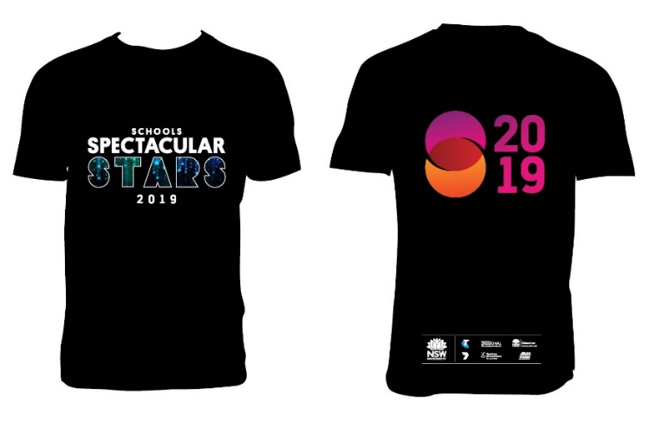
Choir Shirts Approximately 3,000
- T-shirts printed on high quality short sleeve Tees (long sleeve indicated below based on 2019 and will become a short sleeved shirt in 2020)
- Approximate breakdown of 2,200 youth tees; 800 adult tees
- One print size for youth tees
- One print for adult tees
- T-shirts separated and packed according to school orders
- Delivery of tees to approximately 120 school locations by 9 November 2020

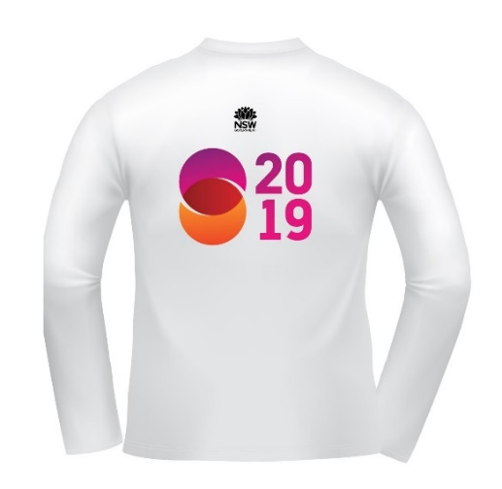

Polos
- High quality polos
- Polo logos embroidered
- Approximate breakdown of 150 Adult size polos in varying sizes
- Polos delivered in individual packets
- Delivery of polo shirts to the Arts Unit location by 1 November 2020

Design Concept of Polo shirts:

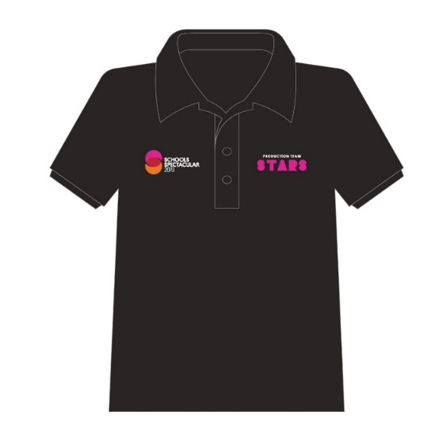
Notes:
- The supplier must provide a system to allow for direct orders from schools for t-shirts and Polo shirts including the purchasing of additional shirts by schools.
- Additional shirts will be ordered in one batch from The Arts Unit.

- Deliverables
- Supply of printed t-shirts and embroidered polo shirts in accordance with the design for the 2020 Schools Spectacular
- Coordination of any modifications in conjunction with the Producer.
- Procedures and capability required for the production and delivery of this project
- Attendance at production meetings as required
- Ensure the delivery is met within the broad schedule and no later than due date
- Possible provision of a direct order system for t-shirts by schools
- Payment schedule to be negotiated; payment on invoice with final payment upon successful completion and deliver of goods

- Pricing
The Contractor is to provide its total fixed price ($AUD) for:
- the supply and delivery of t-shirts and polo shirts in accordance with design for the show
- Allowance for t-shirt and printing/ embroidery
- Allowance for delivery of all merchandise to nominated locations around the state.
- Allowance for the online ordering of shirts and post show reconciliation of revenue
- Provision of high quality shirts and printing
All pricing information must include GST.

RESPONSE
NOTE TO RESPONDENTS: For all questions below please complete your responses in the tables and boxes provided.

- Respondent's details
Entity Name
Australian Business Number (ABN)
Mailing Address
Contact Person Name
Contact Person’s Phone Number
Contact Person ‘s email Address
Is the respondent a small or medium enterprise (SME)? (Yes or No)
* As defined in the NSW Government Small and Medium Enterprises and Regional Procurement Policy
Is the respondent an Aboriginal Owned Business? (Yes or No)
* As defined in the Aboriginal Procurement Policy
Is the respondent an Australian Disability Enterprise (ADE)? (Yes or No)
* As defined on ProcurePoint

- Please set out details describing how each of the Requirements will be met.
If there is a requirement that the respondent cannot meet, it must be set out here.
Please also set out details of anything (e.g. resources, access) that the department or anyone else must provide or make available for the respondent to provide the Deliverables.
- Please provide a high level project plan to demonstrate how the respondent will meet any required timeframes, or if there are no timeframes specified, please provide details of the respondent's timeframes to provide the Deliverables.
- Please provide details of pricing:
- Please provide any additional information to support this response.
- Please provide the contact details of two referees, who are able to verify from personal experience, the respondent's past and/or present performance in the provision of similar services. Please be specific with the description and scale of the good or services provided.
Referee No. 1
Entity's Name
Address
Contact Name
Email Address
Telephone No.
When were Goods or Services Provided?
Description of Goods / Services Provided

Referee No. 2
Entity’s Name
Address
Contact Name
Email Address
Telephone No.
When were Goods or Services Provided?
Description of Goods / Services Provided

Please complete and sign the following:
I confirm, for and on behalf of respondent that the proposal submitted to the NSW Department of Education on date in response to the RFQ number for services/ products complies with the Conditions.
Name:
Signed:
Position:

